| 1

Contact Information:
Prof. N.K. Mondal
Tata Institute of Fundamental Research,
1, Homi Bhabha Road,
Mumbai 400 005.

http:://www.ino.tifr.res.in

http:://www.imsc.res.in/~ino
| 2

| 3

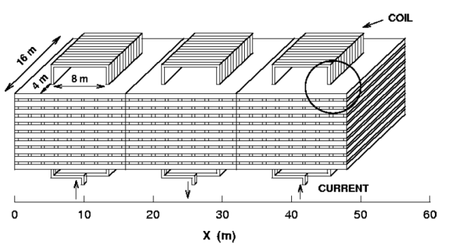 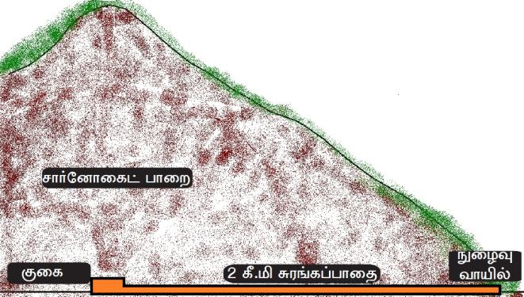
| 4

| 5

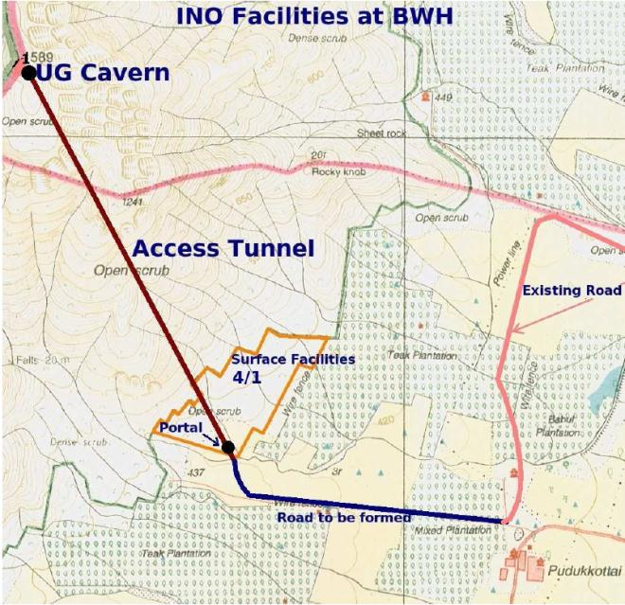
| 6

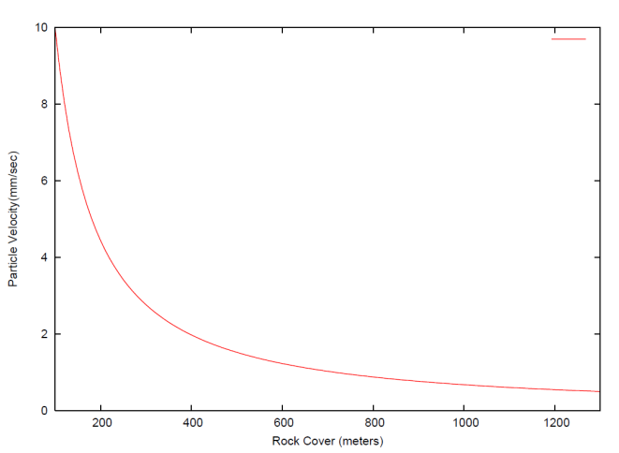
| 7

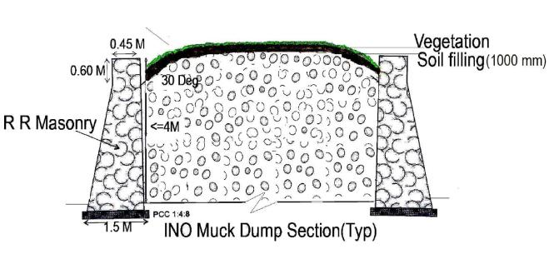

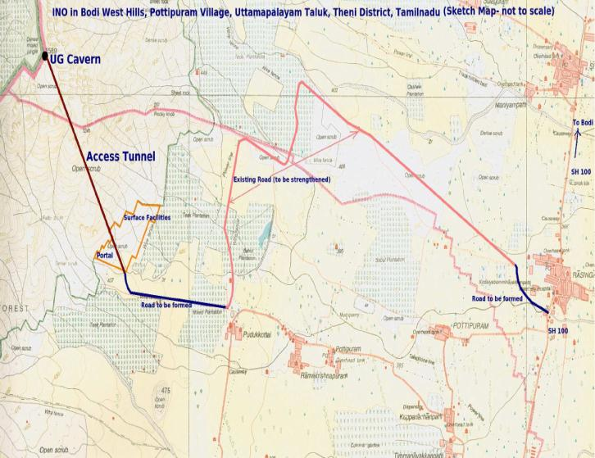
| 8

| 9

| 10

